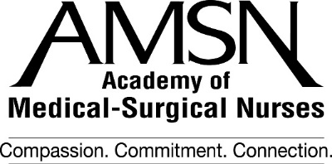
28th Annual Convention – Chicago, IL
Hilton Chicago
September 26-29, 2019
Sponsorship Opportunities

On behalf of the Academy of Medical-Surgical Nurses, we are pleased to provide you with sponsorship opportunities for AMSN’s 28th Annual Convention!

Sponsors will be recognized in publications, signs, and in other high exposure ways prior to and during the convention. The following special programs are available for sponsorship. We encourage you to review the list and choose the areas that appeal to you. Please check the appropriate box for the programs that you are interested in supporting and return this form to the address below. We will call you to discuss and finalize the sponsorship. We appreciate your support of the Academy of Medical-Surgical Nurses.

$1,500 Sponsorship Opportunities
Concurrent Session Speaker
A variety of speakers and topics will be featured

$1,500 Sponsorship Opportunities
Free Standing Meter Boards

$3,500 Sponsorship Opportunities
General Session Speaker
Thursday Friday
One available each day

$4,500 Sponsorship Opportunities
Folders/Writing Tablets
Neck Wallet Badge Holders thank you MSNCB

$4,500 Sponsorship Opportunities
Refreshment Breaks -
Morning (1 available)
Afternoon (1 available)
You may wish to provide mugs/cups for
additional exposure

$5,000 Sponsorship Opportunities
Charging Station
(Company logo on charging station kiosk in
both registration and exhibit area)

$7,500 Sponsorship Opportunities
Mobile App thank you Encompass Heatlth
(Company Logo on landing page & push notifications included)

$8,000 Sponsorship Opportunities
Tote Bags thank you HCA Healthcare

$10,000 Sponsorship Opportunities
Keynote Speaker thank you MSNCB
Medical-Surgical Certification Review Course
(Two day program)

$750 Sidebar / $1000 Leaderboard Banner
$750 Sidebar $1000 Leaderboard
Run a sidebar or leaderboard banner from August 29 thru September 29 on the MEDSURG Nursing Journal’s website www.medsurgnursing.net
reach all the attendees who are coming to the convention. This offer is for exhibitors only and must be PREPAID.

Company Name:
Address:
Contact Name:
E-mail: Telephone:

Please return to: AMSN – Heidi Perret Fax: 856-589-7463
East Holly Ave/Box 56 Phone: 856-256-2375
Pitman, NJ 08071 AMSN Tax ID: 22-3141758
heidi.perret@ajj.com

